High-performance motion control in practice:
Faster = better?!
Fast control technology and dynamic, precise drive components increase the production output of machines and improve the quality and dimensional accuracy of products. This enables machine builders to offer competitive, high-performance solutions. Producers benefit from higher output quantities, and the customer gets a better product. Everybody wins.

Summary:
The selection of drive technology provides the basis for the performance and operating cost of machinery. Drive dynamics have a significant impact on the maximum production output. The precision of drive control affects the quality (e.g. dimensional accuracy) of produced goods, and the efficiency of drives plays a key role in the energy efficiency of the overall solution.
The effective dynamics of drives and the response to rapid setpoint changes also depend on the cycle rates of the positioning motor controller and especially the current controller. Typical current controllers use sampling rates of 0.1 ms (= 10 kHz control cycle), while positioning motor controllers use 1 ms (= 1 kHz control cycle). These controller dynamics are not sufficient for highly dynamic drives with acceleration times of only a few milliseconds.
Massively increasing the current and position control cycles by a factor of 10 enables small drives of up to 500 W to perform highly dynamic movements and offers a solution to the conflict between the design goals of extremely short acceleration times and precise adherence to a motion profile without overshooting.
However, in order to reap the full benefits of such drive solutions, the other system components have to meet certain requirements: dynamic motors, precise position detection, efficient controller optimization, and standardized integration into existing PLC concepts. Only a systematic approach enables the integration of new technologies into practice with a short time to market and low development risk.
Drive technology: Applications
The concrete Application has to be at the focus of any kind of technological progress. Ultimately, improved performance characteristics (e.g. faster control) or new technologies have to yield results in the form of better quality and/or reduced cost. When looking at ways to optimize drive technology, it is advisable to consider the application and its specific requirements first. Drive control technology can nowadays be found in almost all machines and devices. The list below gives a brief overview of the scope of possible applications. However, it is by no means exhaustive:
- Highly complex, “sensitive” surgical robots
- Pick-and-place machines in the electronics industry
- Electrical screwdrivers in medical technology, as well as in the automotive and watchmaking industries
- Filling and packaging machines in the food industry
- Rotary table machines, handling devices, and robots in the toolmaking and automotive industry
- Paper processing and printing machines in the newspaper industry
- Automated storage systems for industry and commerce
- Haptic systems for tactile feedback in remote-controlled robots
All these applications use small or large, low-power or high-power drive units based on different technologies. In combination with positioning or speed/torque control, they become part of various processing steps producing high quality goods at low costs.

Drive technology: The topics
In nearly all applications, there are the same three typical requirements to drive technology, individually or combined:
- Synchronization of several drives
In order to enable high production output, products have to be processed “on the fly” (e.g. cutting, drilling, perforating, printing, labeling) without stopping the material flow. This means that several drives have to maintain a coordinated motion profile (position and speed) at all times. In addition to control technology, this also requires fast data exchange of setpoint and actual value information among all drives and the higher-level controller.
- Dynamic motion through high acceleration
Small, light components have to be moved extremely fast from point to point in short cycles (e.g. within a few milliseconds). The final position has to be reached precisely, i.e. without oscillation. This places especially high demands on the quality and performance of the control algorithm.
- Precision in both positioning and torque control
The motion has to be executed “gently”, i.e. with defined or limited force in order to avoid damage to the workpiece. Current measurement and torque control are particularly important here.

Drive systems: The context is always mechatronics!
Master
(PLC / PC)
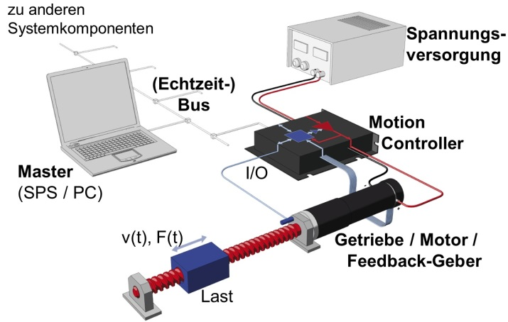  Power supply  Load  (Real-time) bus  to other system components | 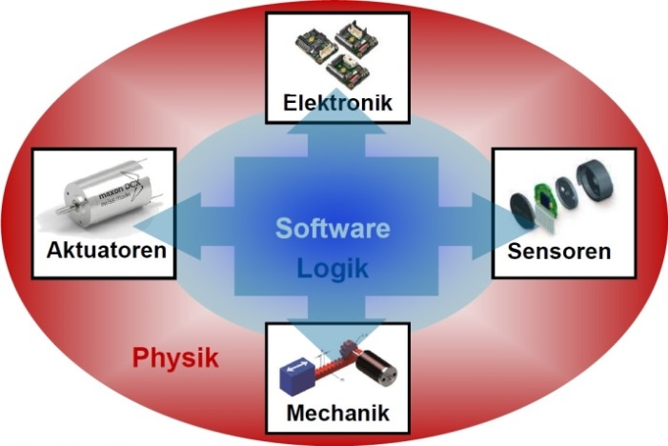  Physics  Logic  Mechanics  Sensors  Actuators  Electronics
Fig. 1: Drive system | Fig. 2: Mechatronics

A typical drive system consists of the following components:
- Higher-level controller, e.g. PLC or PC
- Software for process and drive control (e.g. multi-axis path planning on PLC, PC)
- (Real-time) bus system for data exchange
- Motion controller (incl. power stage) for current, speed, and position control
- Electro-mechanical drive unit consisting of a motor, gearhead, and encoder
- Various sensors, e.g. reference and limit switches, markers
- Mechanical components, e.g. belts, couplings, spindles, etc.
- Power supply for all components
As the list already suggests: An optimal overall system, i.e. a machine or device that is efficient and appropriate to the requirements, cannot be achieved by focusing on the optimization of a single component. The context is always mechatronics: A combination of know-how from mechanical and electrical engineering, drive control technology, and software development. In many cases, experience in application technology is also required.
Mechatronics in practice: Multi-axis synchronization
Multi-axis synchronization is a great example to illustrate the aspects and interdependencies of the various components. This type of system includes all the components listed above.
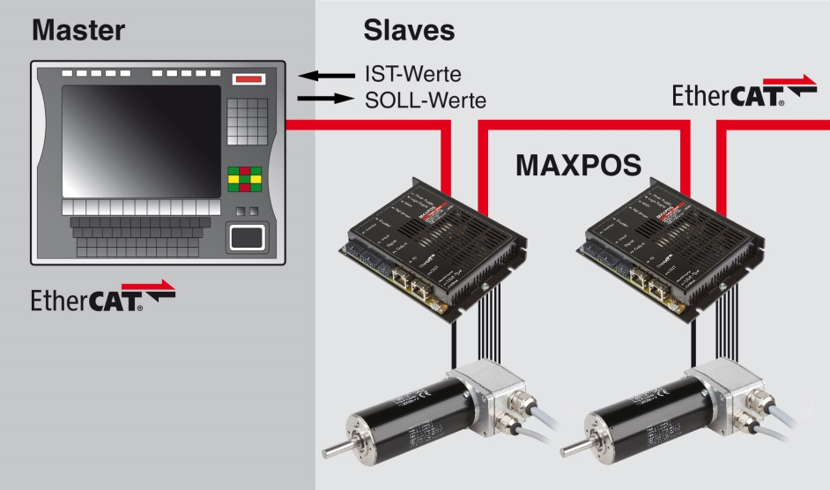
Fig. 3: Master/slave system for machine control
with synchronization/coordination of several drives.
Actual values
Set values
The master (typically a PLC) provides the process control for the system and the coordination (= path planning) of the various drives. Frequently the position control is also performed directly by the master, and the lower-level motion controllers are actuated via current setpoints. This enables the master to monitor interdependencies between axes and command precisely coordinated multi-axis movements. The system concept is suitable for requirements-based integration of motion controllers from various manufacturers and with different performance ratings. The machine can be configured and programmed with a unified programming tool (e.g. TwinCAT®) and motion control libraries of the master's supplier (e.g. PLC). Lower-level motion controllers need to have a very fast bus system (e.g. EtherCAT) and conform to an established communication standard (e.g. CiA402 for electrical drives).
Such tightly coupled systems place special requirements on the individual components:
- Master system with fast data processing and multi-axis path planning
- Data exchange between master and slaves in real time, i.e. with a unified, fast bus system and standardized bus protocol
- Fast lower-level controllers in the motion controller and support for established industry standards (device specification)
- Dynamic motors
- High-resolution encoders
- Precise mechanical systems

Focus: Motion controller
The basic functionality of any motion controller is to regulate the motor current and the power supplied to the motor. Many motion controllers also offer speed and position control. However, especially in multi-axis systems, these control loop functions might be even processed centrally by a higher-level PLC.
The result of optimal interaction between the master and slave controllers is maximum precision, dynamics, and synchronization of commanded motion profiles. The quality and performance of the control algorithms as well as bus communication play a central role.
The economic benefit of fast controllers and optimal interaction between all components is higher production output at the same or even better quality (e.g. dimensional accuracy) of the produced goods.
Focus: Controller performance
A comparison shows the performance differences of modern motion controllers (e.g. maxon MAXPOS 50/5) and products that have been established in the market for years:
 | Cycle times
 | maxon MAXPOS 50/5  motion controller | Typical industrial motion controller
Current controller | 0.01 ms (100 kHz) | 0.1 ms (10 kHz)
Speed controller | 0.10 ms (10 kHz) | 1.0 ms (1 kHz)
Position controller | 0.10 ms (10 kHz) | 1.0 ms (1 kHz)
Min. bus cycle time | 100 μs (CST-Mode)  200 μs (other modes) | typ. 1000 μs
The latest generation of the maxon MAXPOS 50/5 controllers offer ten times better performance with respect to current, speed, and position control than traditional motion controllers and power stages. An interesting feature of the current controller is its ability to perform sinusoidal commutation for motor speeds up to 200,000 rpm. Sinusoidal commutation is extremely demanding in terms of processing power. However, it offers the benefit of an almost ripple-free, constant torque within each revolution, irrespective of the rotor position.
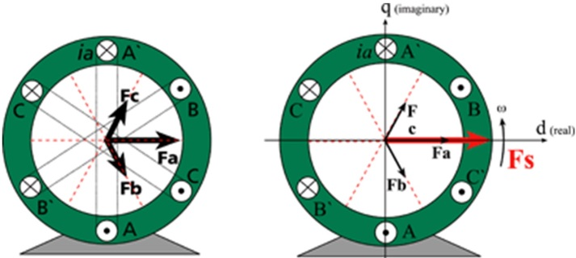 | 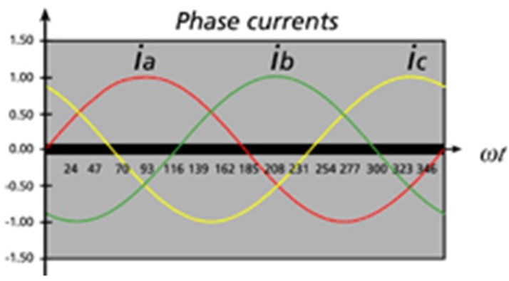
Fig. 4: Sinusoidal commutation of the motor current
A current controller cycle of 100 kHz means: 100,000 times per second…
… the current is measured in all motor phases
… signal conversions, complex integration calculations, and transformations for current control and sinusoidal commutation are performed independently of all other functions in an extremely short time (10 μs)!
Highly dynamic current control in practice
The best way to test the dynamics and quality of a controller and drive system is by analyzing its step response, i.e. the response to a sudden change in the set value. The following graphic shows the step response of the MAXPOS 50/5 current controller with a 100 kHz cycle and that of a typical industrial current controller with a 10 kHz cycle.
With a 100 kHz controller, the actual current stabilizes at the setpoint after only 150 μs
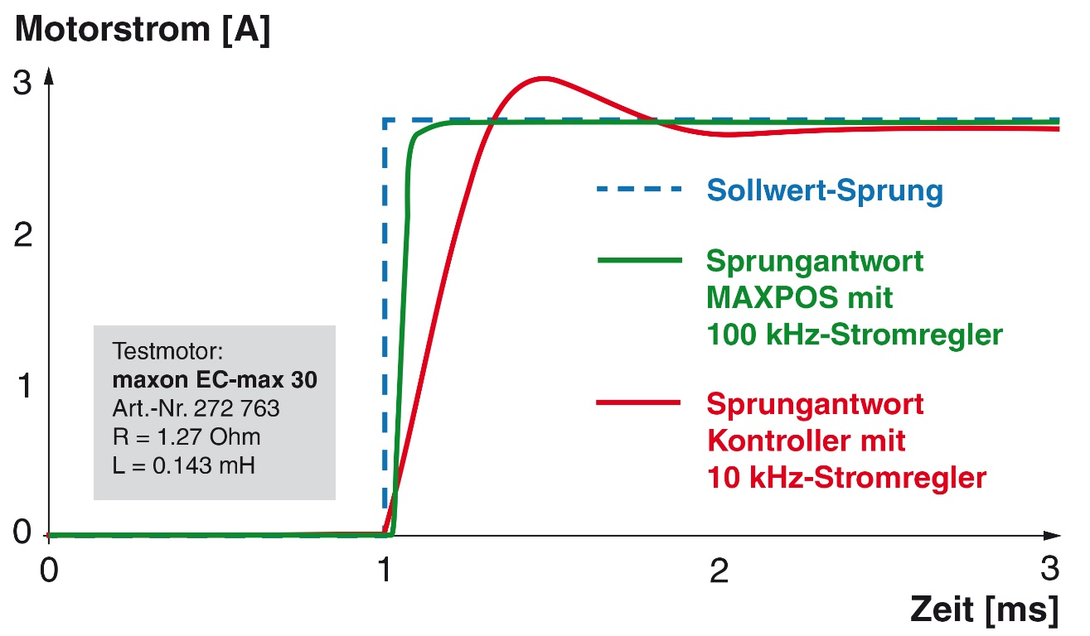
Fig. 5: Step response of current controller
Step in set value
Step response of controller with 10 kHz current controller
Step response of MAXPOS with 100 kHz current controller
Test motor:
maxon EC-max 30
Part no. 272 763
R = 1.27 Ohm
L = 0.143 mH
Time [ms]
Motor current [A]
The step response (fig. 5) clearly shows that, after the set value change (at t = 1 ms) …
… the actual current stabilizes at the setpoint after only 0.15 ms for the 100 kHz current controller, basically without overshooting.
… the 10 kHz current controller of an established competing product takes 0.30 ms until it reaches the current setpoint and significantly overshoots it. This controller reaches a stable condition only about 1.2 ms after the step in the set value.
Note:
The steepness of the current curve, the amount of overshooting, and the settling time depend on the control parameters. It is a compromise that can be optimized differently depending on the requirements of the application. While a steeper current gradient like the one for the 100 kHz controller can be achieved with the slower 10 kHz controller, the price would be a significantly higher amount of overshoot and a longer settling time.
Why does the 100 kHz current controller have such big advantages under identical conditions of use, and what are the practical benefits?
The 10 kHz motion controller performed only 3 current measurements and control calculations during the 0.3 ms (fig. 5) before the current setpoint is reached for the first time. The controller is able to follow the dynamic reaction of the motor, or of its electric circuit (τ = L/R) only to a limited extent. Significant overshoot occurs despite the slow current ramp-up, and a comparatively long time passes until a stable motor current state has been reached. Such a controller is not very suitable for quick, precise movements, because the settling time always has to be taken into account. This prolongs every machine or processing cycle, and the overshoot may impact the quality of the products. For a torque-controlled screwdriver or press-in device, the specified torque is significantly exceeded during the peak.
The fast 100 kHz current controller of the MAXPOS motion controller performs a total of 15 current measurements and control calculations in 0.15 ms (fig. 5). This means that it responds to every fluctuation in the motor current virtually without any delay. It is capable of following and precisely controlling the motor current even in highly dynamic low-inductance motors with very small mechanical and electrical time constants. The setpoint is reached very quickly depending on the motor's electrical time constant (τ = L/R). No significant overshoot occurs. Each operation of a machine can be executed quicker and with higher precision in accordance with the process specifications.
Focus: Master and bus system
A controller is always integrated in an overall system from which it receives its commands. For faster controllers, the question is: What are the specific requirements that the master and the bus system have to fulfill to make use of high controller dynamics and performance? As a rule of thumb, higher-level controllers can be slower than the commanded, lower-level controllers by a factor of 10.
For complex multi-axis systems, the path planning of all axes (i.e. the precalculation of motion profiles) and the position control often take place in the master. The master commands the individual drives in speed or current control mode. For directly commanding a fast 100 kHz current controller, the data exchange via the bus should therefore take place with a 100 µs cycle (= 10 times slower than the current controller cycle). Modern PLCs with real-time capable bus systems (such as EtherCAT, Powerlink, Profinet, Sercos-III) are able to comply with this requirement. Older bus systems like CAN or Profibus on the other hand do not offer sufficient performance. These buy systems are typically sending speed or position set values to lower-level motion controllers in a 1 ms cycle. The maximum data exchange rate of up-to-date feedback values (speed, position, motor current, sensors, operating states etc.) and set values quickly reach the limit in the case of older bus systems and multi-axis applications, due to the lower bus bandwidth.
During the concept phase, the choice of the bus system has an indirect impact on the ability to utilize the full performance of state-of-the-art motion controllers and drive technologies. The MAXPOS series of motion controllers therefore relies on EtherCAT as a modern, high-performancebus. Older bus types that would limit the overall performance are no longer supported.
Focus: The motor
The motor is the interface between the electrical and mechanical parts of the system. It converts the current generated by the motion controller and its power stage into mechanical motions. Its performance is critical for the effective maximum dynamics of the mechanical motion. A dynamic motor offers very good acceleration, which is based on a low mechanical time constant. A motor's dynamics are influenced by three key factors:
- Low rotor inertia
Motors with a low rotor inertia reduce the torque required to accelerate the rotor and increase the energy efficiency.
- High efficiency
A high efficiency means that the current supplied to the motor is optimally used for the generation of torque to accelerate the rotor and the load. High efficiency therefore improves the dynamics, increases the energy efficiency and reduces the heat generation (an important factor for hand-held devices).
- High overload capacity
Motors with high overload capacity can be exposed to currents that are several times higher than the specified nominal current for a short time. These short-term peak currents are ideally suited to provide the torque for high acceleration. A drive with a high overload capacity can be optimally designed for the effective nominal power without having to oversize it just to accommodate a few short-term peaks.
Motors that optimally fulfill these three factors are able to accelerate to their rated speed in only a few milliseconds (or to decelerate just as fast).
Focus: Encoders, mechanical components –> positioning accuracy?
The encoder system supplies actual values to the motion controller for position and speed calculation. The higher the resolution of the encoder system (relative to a turn of the motor shaft), the more accurate can the current position and speed be determined.
However, a high-resolution encoder system does not necessarily deliver an equally high positioning accuracy from an application perspective. For control reasons, the encoder system has to be rigidly connected to the motor's rotor shaft. In practice, the positioning accuracy of the motion linked to the output shaft (e.g. linear spindle, belt, etc.) is usually more relevant. Gear backlash, elastic couplings, slippage, as well as controller quality and the fine-tuning of control parameters may reduce positioning accuracy.
A higher-resolution encoder usually provides better actual value information for control, in particular for low speeds. However, this does not necessarily result in more precise positioning on the output side. Here, the mechanical coupling between the motor shaft and the unit being positioned (and their backlash and slippage) is also a crucial factor.
So-called dual-loop systems with one encoder on the motor shaft and a second encoder or linear scale on the output may help to compensate the gear backlash and slippage. However, they also increase the system cost due to the higher number of components required, and reduce the dynamic of the positioning process due to a longer settling time at the target position. In practice, dual-loop systems are therefore used only in a small number of specific application cases.
Pitfalls?
As with all projects, there are pitfalls that may not become apparent until later in the project. Due to the nature of mechatronics, these pitfalls may be in the software, or they can be mechanical, electrical, or in electronics.
One challenge is the power specification of the entire chain, from the motor to the power stage of the motion controller and to the power supply. For this chain, it has to be considered that short bursts of acceleration may require very high current peaks. In particular the power stage has to be able to deliver this peak current for a specified time. If such bursts of acceleration occur in cycles, then the resulting RMS current is the crucial value for the selection of the motor power and the power stage of the motion controller. For the dynamic deceleration of drives, energy is fed back from the motor to the power supply unit via the power stage of the motion controller. Industrial power supplies have appropriately sized internal buffer capacitors for “storing” this energy. The popular (due to compact size and low cost) plug power supplies on the other hand have difficulties coping with short-term current peaks and energy feedback. The installation of additional buffer capacitors may be necessary. For longer deceleration processes, a so-called shunt regulator may be required.
Optimization – but how?
Detailed knowledge of the application requirements is always the starting point for optimization. The selection of components has to be reviewed and fine-tuned holistically under this aspect. It is well known that the performance of a system is determined by its weakest link. Machine performance starts with drive technology. Consultation with experts in mechatronics and drives, as well as component suppliers with years of experience in applications and development, may broaden the perspective and contribute significantly to considering a variety of solutions right from the start and finding the optimal way.
High-performance motion control in practice: The benefits
- Dynamic controllers and motors mean that less time is lost before a current, speed or position setpoint has been reached precisely and in a stable manner.
- This allows motions to be executed faster and more precisely.
The settling time for the actual value to stabilize to the set value is much shorter.
- Precise torque curves allow for “gentler” handling and processing of sensitive products.
The benefit for machine/equipment builders
Optimal drive technology may significantly contribute to increasing the production output of a machine and improving the quality of the produced goods. This ultimately increases the efficiency, cost effectiveness, and competitiveness of machines and systems. It is crucial that manufacturers of machines, systems, and equipment make the right decisions regarding the drive technology in the early stages of the project, maybe taking a redesign of “proven” concepts into consideration. A supplier who is able to provide advice based on long years of application experience and current trends may help to reduce development risks and cost. Finally this also helps to shorten the time to market and reach the break-even point quicker. The selection of the right components and partners yields measurable results in all areas.

A true drive specialist like maxon motor has more to offer than catalog products and off-the-shelf consultation:
  - Partnership in the design and development stage
  - Assessment of solutions based on comprehensive application experience
  - Engineering in the entire context of mechatronics
  - Application-oriented drive specification and consultation
  - Catalog products for quick deployment and testing
  - Customized solutions for medium and large-scale series
  - Reduction of development risks through proven industrial design
  - Reduction of the time to market through early-stage prototype testing

Contact:
Headquarters
maxon motor ag
Brünigstrasse 220
6072 Sachseln
Switzerland
Phone: +41 (41) 666 15 00
Web: www.maxonmotor.ch

